ABSEL Proceedings Guidelines

Title (16 Font, Times New Roman, Centered, Bold)

Author Name (12 Font, times new Roman, Centered)

Author Affiliation (12 Font, times new Roman, Centered)

Author email (12 Font, times new Roman, Centered)

# ABSTRACT (12 Font, times new Roman, Centered, Bold)

This is a demonstration of an ideal submission. Abstract italicized at size 10 font, Times New Roman, Left Justified.

# INTRODUCTION (12 Font, times new Roman, Centered, BOLD)

This document should provide necessary information for the minimum submission format. Consider this a base document for correctly formatting your paper. Use Times New Roman, size 10 font, single-spaced for all body text. In some cases, as you format, headings or elements will be split over 2 pages. Do not worry about these, the Format Editor will adjust them to keep them together and visually appropriate and consistent in the final publication. Everything should be Left aligned, except for headings (or other exceptions listed below), with 1 line of return between each heading or paragraph as demonstrated in this file.

# Titles and Headings (12 Font, times new Roman, Centered, BOLD)

Main Headings, such as Abstract, Introduction, Conclusion, Summary, References, etc. Should be centered, ALL CAPS is preferred, Bold, Size 12.

## Subheading (10 Font, Times New Roman, Left Aligned, Italicized)

Subheadings are used for example paragraphs, and general subtopics. Heading 2 should be left aligned, Size 10 font, Bold, Italic.

## Body Text

Body Text should be Size 10 font, Times New Roman, Left Aligned. Underline and Italicize within your paper as usual for emphasis.

## Lists

Lists, such as bulleted lists should be Size 10 font. Bullet points, Numbered lists, and Outline formats can be left as originally included in submission (per Track Chair’s guidance on edits and corrections).

* Use lists as typical
* They will be adjusted for consistency in visibility
* They will not be moved from the location assigned by the author(s)

1. Numbered, lettered, and Roman Numeral lists are all acceptable.
2. There really isn’t a lot of change from normal use.

## Figures, Charts, Tables, Images, etc.

Tables, charts, images, examples, equations, etc. are to be added at the end of the paper, following all ancillary material and appendices. Indicate within the body of the text the ideal location with the following notation:

*************Figure 1 about here****************

All items will be placed as close as possible to the desired location as indicated but is dependent on the editor’s discretion. Whenever possible, please convert tables and charts to image format. This can be done by highlighting and copying the table, then using the “Paste Options” Image icon. As shown in the image below.

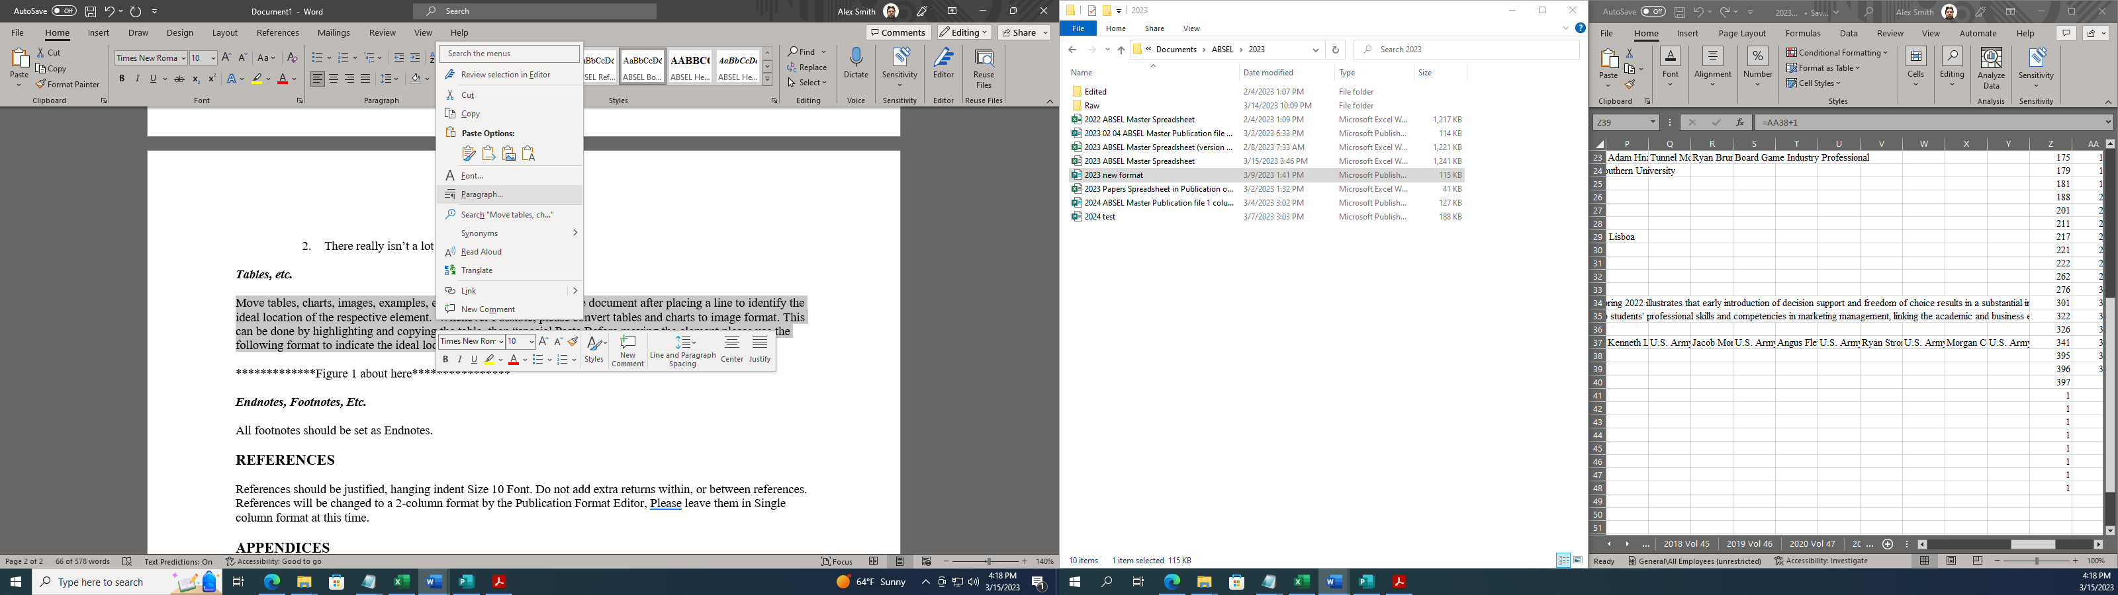

## Endnotes

ABSEL only publishes Endnotes. Footnotes will be discarded.

# REFERENCES and Citations

Citations should use APA (7th ) edition formatting. Information at the following website may be helpful.

https://owl.purdue.edu/owl/research_and_citation/apa_style/apa_formatting_and_style_guide/index.html

References should be Single column, left aligned, Size 10 Font. References are single-spaced; Do not add extra returns within or between references.

Examples:

American Psychological Association. (2020). *The publication manual of the American Psychological Association* (7th ed.).

Gentry, J. W., Burns, A. C., Dickinson, J. R., Putrevu, S.,Chun, S., Hongyan, Y., Williams, L., Bare, T., Gentry, R. A. (2002). Managing the curiosity gap does matter: What do we need to do about it?, *Developments in business simulation and experiential learning*, 29 (Vol. 29, pp. 68-73).

Seas, K., &amp; Brizee, A. (n.d.). *APA style introduction*. Purdue Online Writing Lab. Retrieved July 23, 2020 from https://owl.purdue.edu/owl/research_and_citation/apa_style/apa_style_introduction.html

# APPENDICES

Appendices should be placed after the References section but before the tables and other elements. Format as you want it to appear. When possible, the editor will maintain that formatting. If author(s) want each appendix to begin on a new page, add a page break between appendices. If more than one appendix can be placed on the same page, then leave them in normal succession using the ABSEL formatting guidelines.

**Headers, Footers, and Page Numbers**

Do NOT include headers, footers, or page numbers. The editor will apply correct publication-specific information. It is preferred that author(s) do NOT add any information as the editor will then need to remove this formatting from your document before adding the correct publication headers and footers.